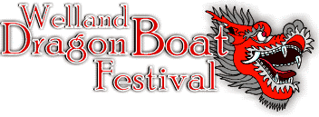

Sponsorship Package

Welland International Flatwater Centre
Welland, Ontario, CANADA

Welland Recreational Canal

What Is Dragon Boat Racing?

Dragon boat racing has evolved into one of the fastest-growing athletic events in the world, and Canada has emerged as a world power in a sport which has historically been dominated by Asian countries. It is a fun, outdoor, family-oriented activity that combines culture and tradition with teamwork and strategy-building skills.

Dragon boat racing, the ultimate team sport, is growing exponentially in corporate and community centres worldwide. Dragon boat racing is:

➢ Experiencing an annual growth rate of 30% to 40%
➢ A fantastic opportunity for corporate team-building and promotion

Dragon boats are the largest flat-water racing canoes in the world. A crew of 20 paddlers paced by a drummer at the bow and guided by a steersperson at the stern combine power and rhythm to achieve maximum acceleration and speed over a 500-metre course. Dragon boating is unique in that total novices can compete with very little training or instruction. A perfectly synchronized team is not only visually spectacular but almost always defeats a stronger but less coordinated competitor.

Here are just a few of valuable benefits your organization will receive by participating in the 2018
Dragon Boat Festival:

➢ A fresh, untapped and uncluttered marketing opportunity
➢ Exposure to over 2,000 participants and spectators of all ages
➢ Extensive publicity and recognition as a sponsor of this event
➢ Involvement in an event which is high on the fun, fitness and friendship scale
➢ Community exposure in a visually spectacular setting
➢ Valuable public relations benefits through on-site event promotion and publicity

The 17th Annual Welland Dragon Boat Festival is being organized by the Welland Heritage Council & Multicultural Centre, a non-profit organization, and will take place on Friday, June 8 and Saturday, June 9, 2018. In the past the festival has featured a youth division, allowing high school students the opportunity to participate in this thrilling event, and a ladies’ breast cancer survivor division.

Welland’s world-class flatwater courses were selected as one of the venues for the 2015
Pan Am games. Your sponsorship of an exhilarating water sport held at the Welland International
Flatwater Centre would continue the support for this world class facility.

Dragon Boat Festival Event Overview

Welland Recreational Canal

Date: Friday June 8 and Saturday June 9, 2018

Time: Friday: (Practice Sessions) – 4 pm – 8 pm
Saturday: 8:00 am – 5:00 pm (Approximately)

Location: Welland International Flatwater Centre (between Humberstone Rd. &
Ontario Road)

Projected Participants: 30-40 Teams – Approx. 1,000 Athletes

Projected Spectators: 1,200

Description: The Dragon Boat Festival caters to a variety of groups, including families, competitive sports enthusiasts, and those who crave outdoor summer activity on Canada’s best dragon boat regatta course.

Personal satisfaction, team development and friendship are key words attributed to the sport. Many companies, organizations and schools have found that the social atmosphere and team- building aspect of dragon boat racing is a valuable tool for assisting individuals to interact in a friendly and constructive manner.

Friday’s activities include team practice sessions with instructors from the Lively Dragon Club of Burlington. Lively Dragon also provides the dragon boats, paddles and life jackets for participants.

Saturday activities include the dragon boat races, food, beverages and other vendors.

Dragon Boat Racing In Welland

Welland Recreational Canal

The 17th Annual Welland Dragon Boat Festival will be held in 2018. A total of 31 teams competed in the 2017 event, resulting in over 2,000 people participating as competitors and spectators throughout the day. Excellent media coverage was received both preceding and following the event by the Welland Tribune and Niagara This Week.

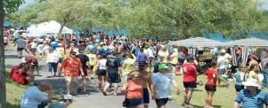
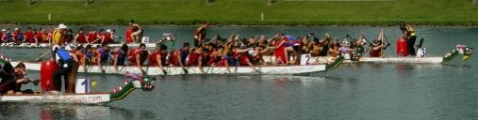
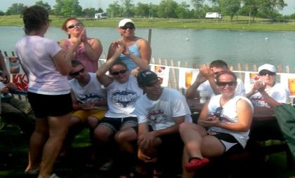
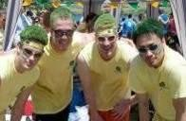
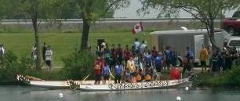
Welland Dragon Boat Festival Photos

Sponsorship Options

There are five sponsorship levels – Diamond, Gold, Silver, Bronze and Media Sponsor, plus our premium Signature Title Sponsorship. Funds received will be directly used to offset the costs associated with the Welland Dragon Boat Festival.

Welland Recreational Canal

Signature Title Sponsor: $10,000 (Five-Year Contract: $2,000 Per Year)

• Advertising on festival website
• Newspaper advertisements/press releases/photo opportunities
• Company name and logo “Presents” in all media releases, print & electronic ads
• Opportunity to present unique championship trophy bearing your company name to winning team
• Corporate identification in the festival name
• Event banners promoting your company
• Display of corporate name/logo throughout event location
• Corporate name and logo on all event material
• First right of refusal re: sponsorship renewal
• Continuous PA system acknowledgement on site during event
• Corporate representation at awards ceremonies
• Set up your own corporate display tent on-site
• Two team entries
• Company name and/or logo featured as Title Sponsor in all printed material including but not limited to event brochure, event program, posters, event T-shirts, an on-site corporate thank-you banner and on the Dragon Boat Festival website

Diamond Sponsor $3,000 For One Year

• Ten 20-second PA announcements during the event
• One team entry
• Company name featured in newspaper advertisements/press releases/photo opportunities
• Company name and/or logo featured as Diamond sponsor in all printed material including but not limited to event brochure, event program, posters, event t-shirts, an on-site corporate support thank-you banner and on the Dragon Boat Festival website

Gold Sponsor 3 available @ $1,500 For One Year

• One team entry at a cost of $375 instead of $805
• Ten 20-second PA announcements during the event
• Company name and/or logo featured as Gold sponsor in all printed material including but not limited to event brochure, event program, posters, event t-shirts, on-site corporate
support thank-you banner and on the Dragon Boat Festival website

Welland Recreational Canal

Silver Sponsor 5 available @ $1,000 For One Year

• Ten 20-second PA announcements during the event
• Company name and/or logo featured as Silver sponsor in all printed material including
but not limited to event brochure, event program, posters, event t-shirts, on-site corporate
support thank-you banner and on the Dragon Boat Festival website

Bronze Sponsor 8 available @ $500 For One Year

• 5-20 second PA announcements during the event
• Company name and/or logo featured as Bronze sponsor in all printed material including but not limited to event brochure, event program, posters, event t-shirts, on-site corporate
support thank-you banner and on the Dragon Boat festival website

Media Sponsorship Package $2,000 For One Year

• Unique “Media Sponsor” trophy to be awarded to the community team posting the fastest race time of the day.
• One team entry
• 5-20 second PA announcements during the event and promotion by Giant 91.7 radio
• Company name and/or logo featured as Media Sponsor in all printed material including but not limited to event brochure, event program, posters, event t-shirts, on-site corporate
support thank-you banner and dragon boat festival website

Please make cheques payable to: The Welland Heritage Council & Multicultural Centre

Conclusion

Without support from companies such as yours, this festival, and the benefits it can provide to the community cannot be fully realized. Supporting the Welland Dragon Boat Festival facilitates an active recreational teambuilding event and serves as a successful vehicle for corporate exposure and the recognition of your commitment to support the community.

The Welland Heritage Council & Multicultural Centre would like to thank you for your time and

Welland Recreational Canal

consideration of this proposal, and look forward to your sponsorship in helping to build bigger and better festivals in years to come!

For more information contact:

Welland Dragon Boat Festival
c/o The Welland Heritage Council & Multicultural Centre
26 East Main Street
Phone: 905-732-5337
Fax: 905-732-0212

Email: info@wellanddragonboatfestival.com
Website: www.wellanddragonboatfestival.com

